

K4 CSF3133 REKA BENTUK ANTARA MUKA BERASASKAN WEB
LAB REPORT 4
SEMESTER 3

PREPARED FOR: ASSOC. PROF. TS. DR. WAN NURAL JAWAHIR
LAB ASSISTANT: MISS WAN FATIN

PREPARED BY: AKMA ASYIFA BINTI ZULKARNAIE
NO. MATRIC: S75186
SUBMISSION DATE: 12 November 2025

Lab 4 – Cascading Style Sheets (CSS) – Part 1
4.2 Page Structure Elements
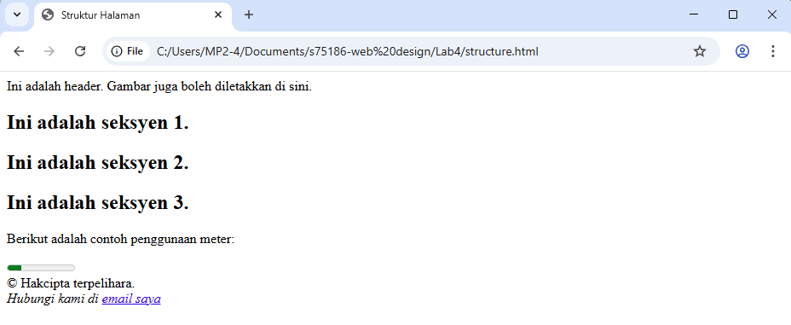

4.3 Insert Video into HTML5 Document
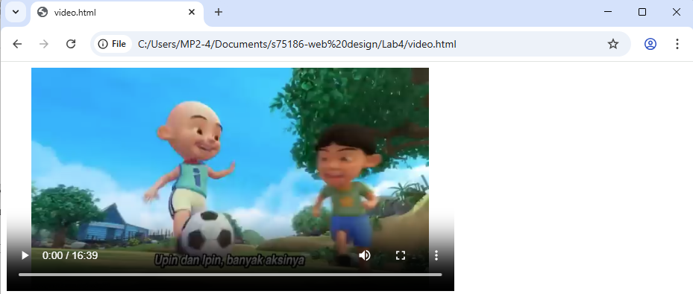

4.4 Cascading Style Sheets
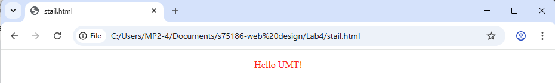

4.5 Recognize ID and Selector Class
stailID.html
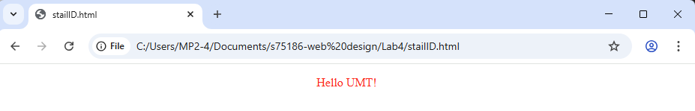
Class.html
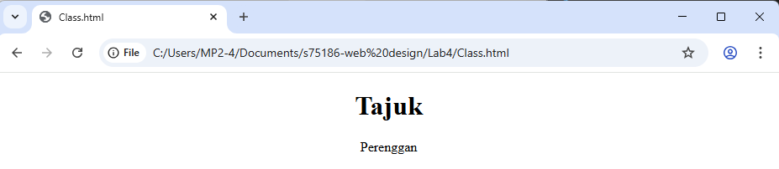

4.6 Navigation Bar using CSS
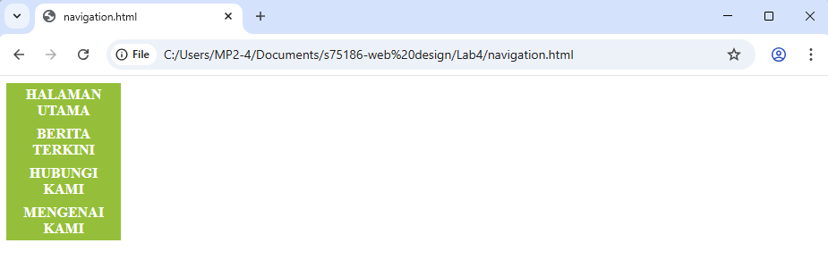

4.7 Recognizing Text Decoration
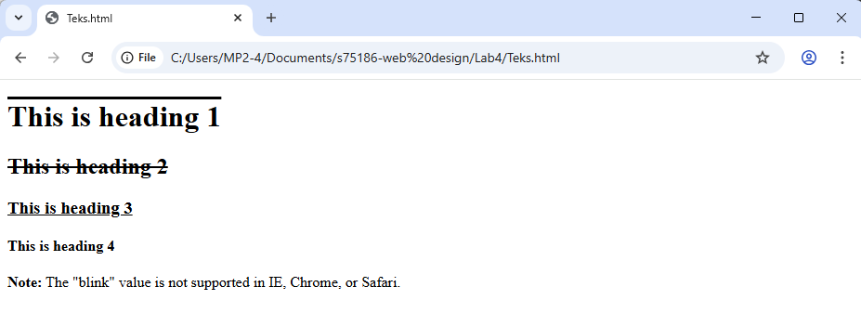

4.8 Recognizing Styling Links

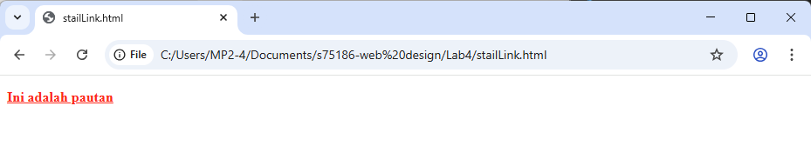
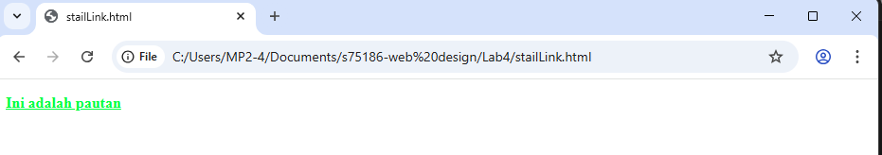
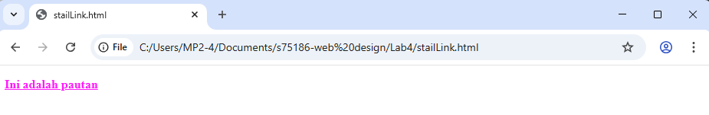
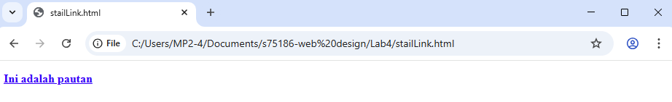

4.9 Lab Exercise 4
4.9.1 Building a Responsive Webpage with HTML5 and CSS
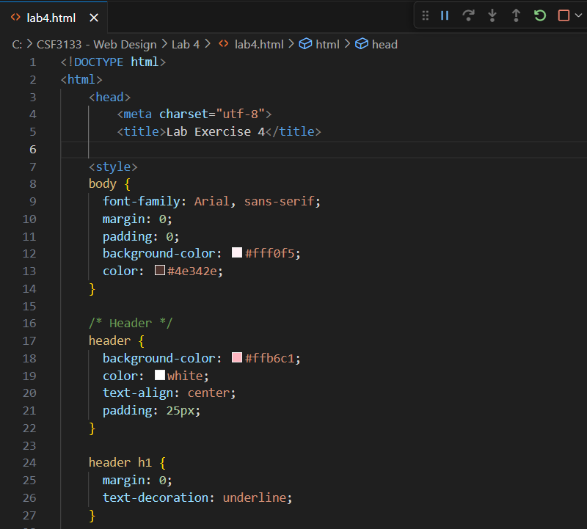
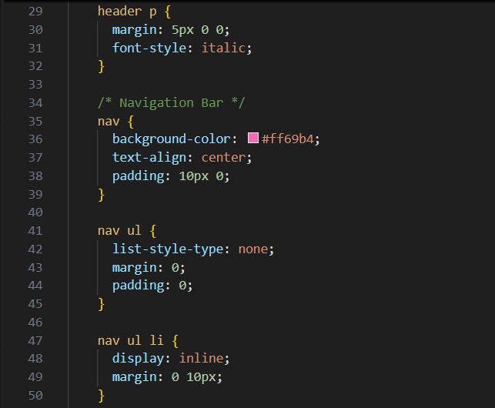

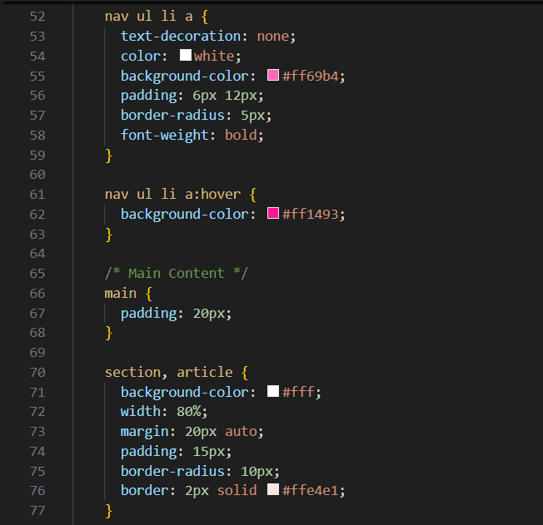
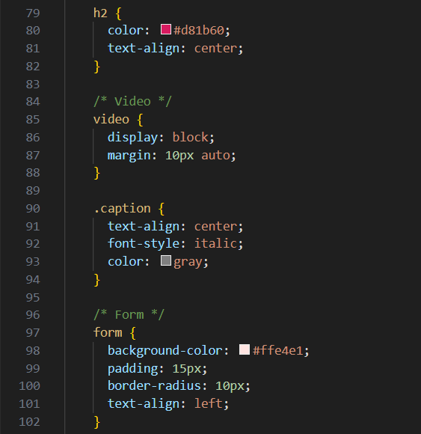

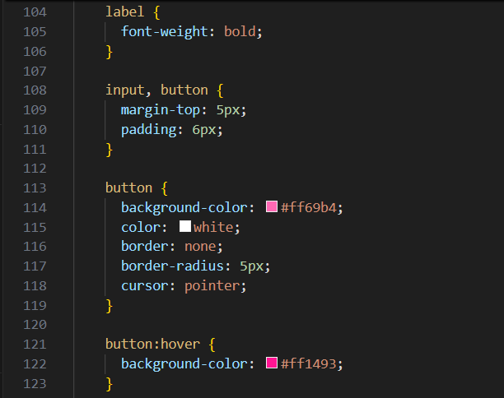
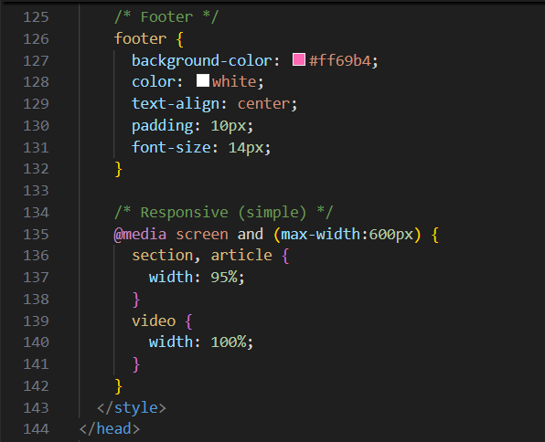
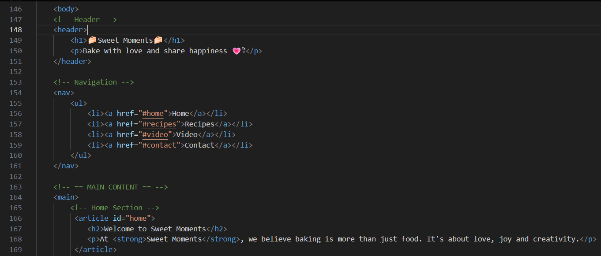
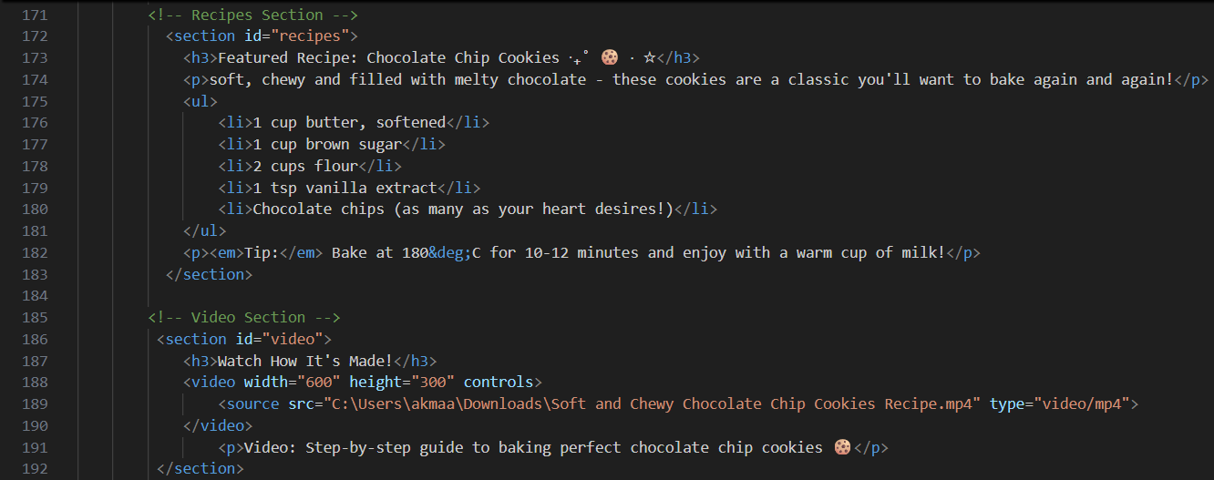
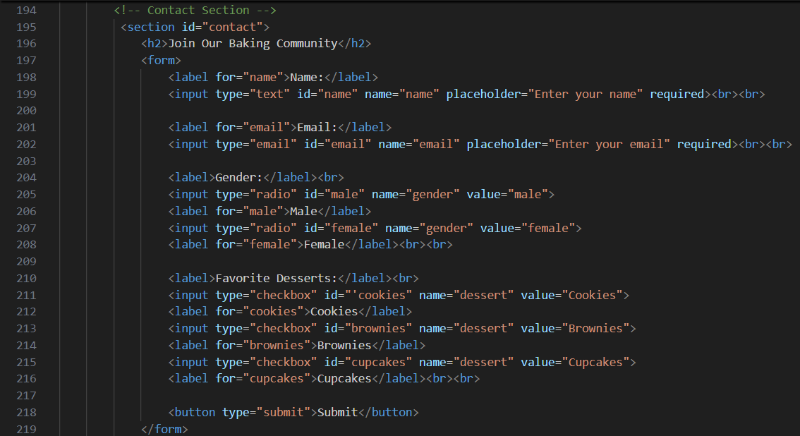
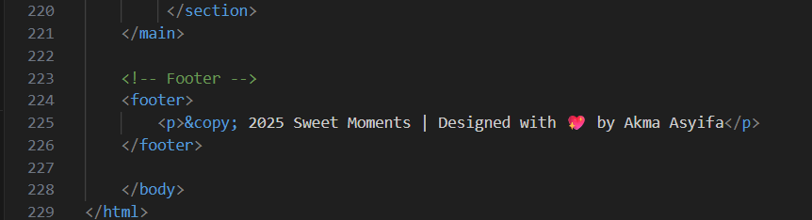

Output
